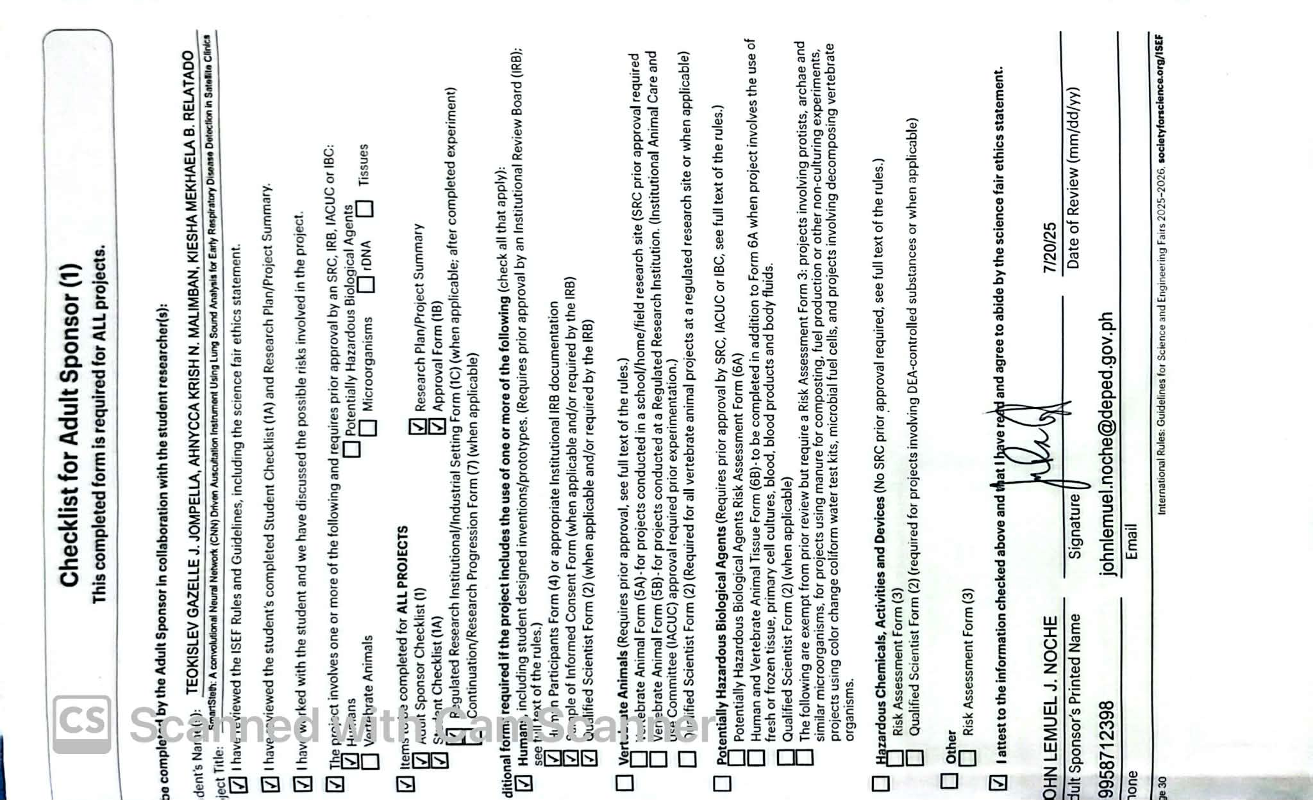

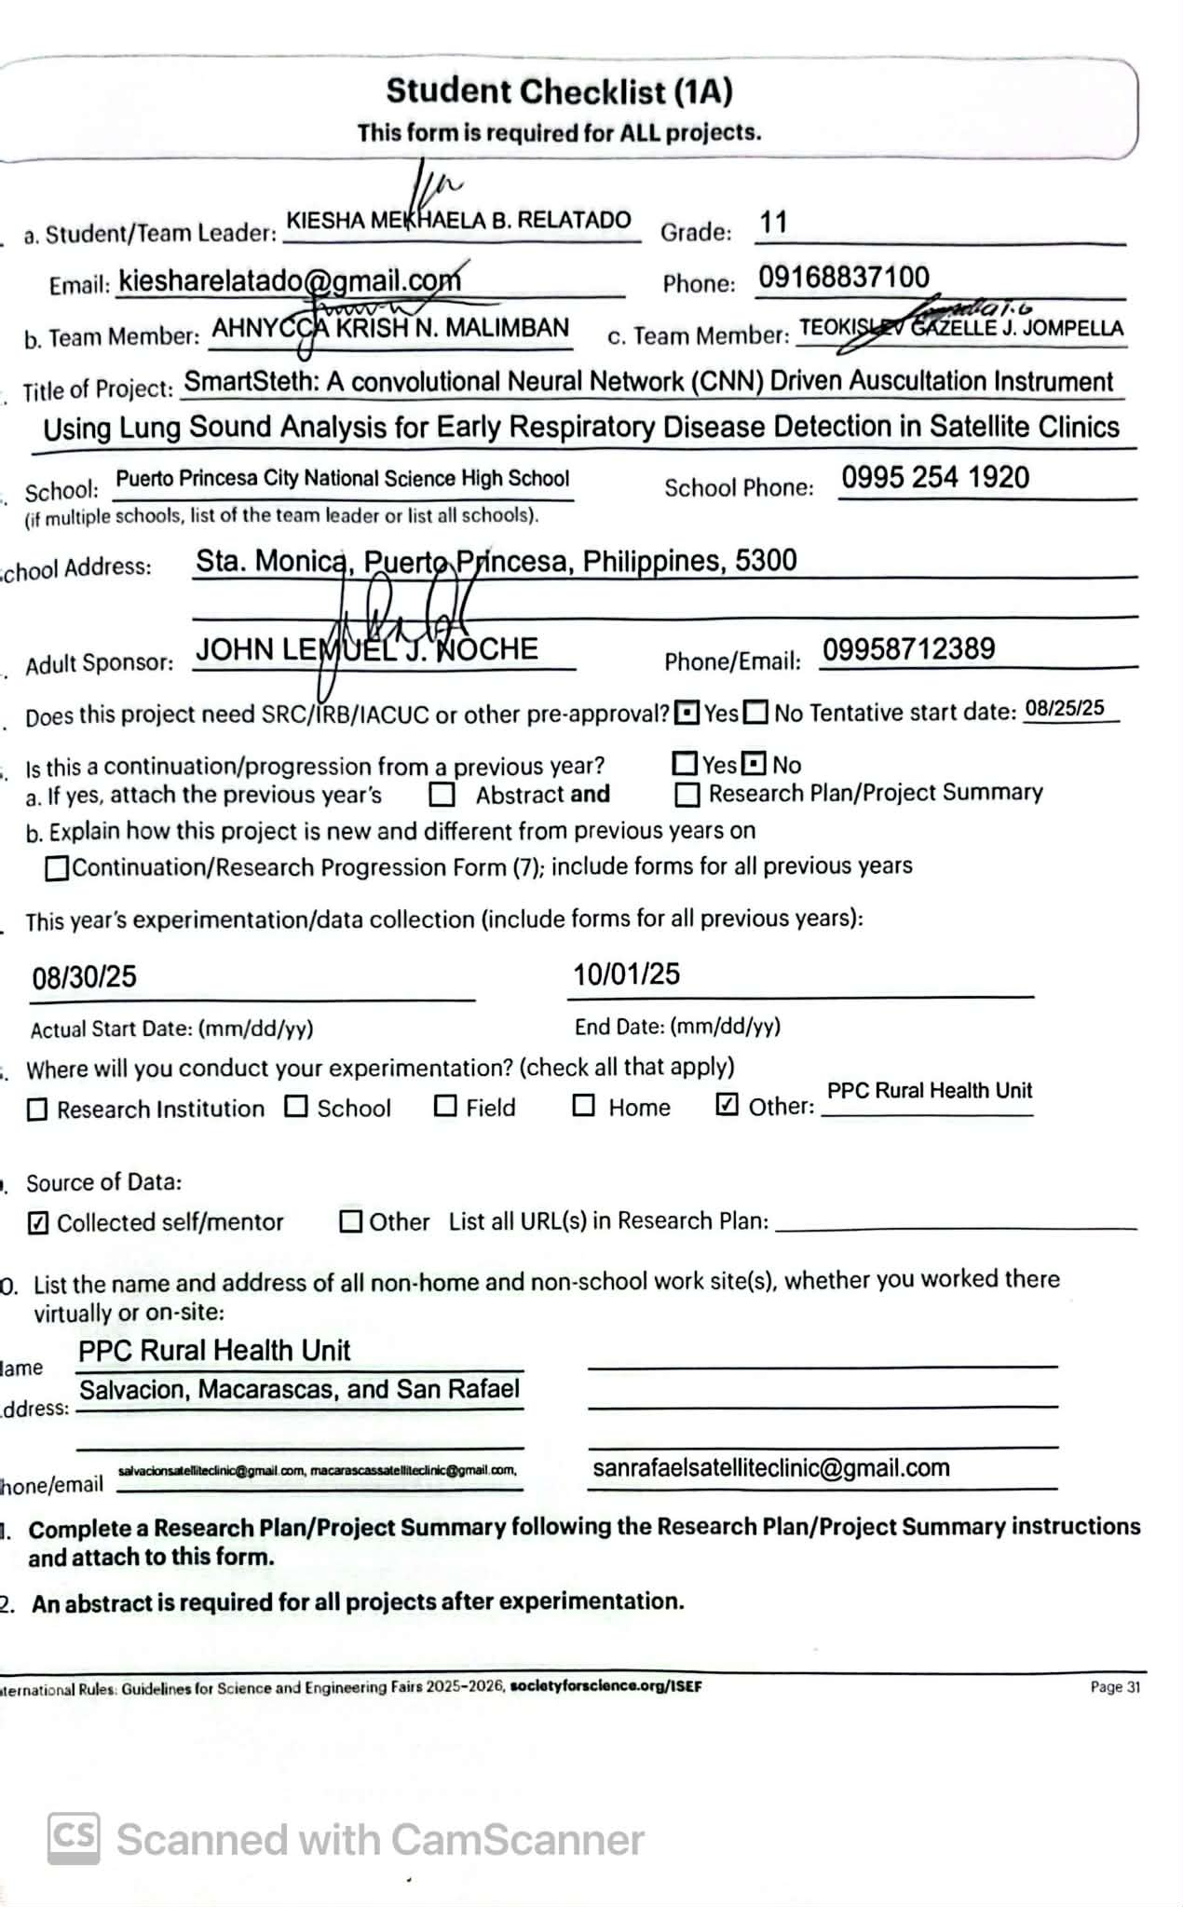

Research Plan/Project Summary Instructions
A complete Research Plan/Project Summary is required for ALL projects and must accompany Student Checklist (1A).
- The Research Plan is to be written prior to experimentation following the instructions below to detail the rationale, research question(s), methodology, and risk assessment of the proposed research.
- If changes are made during the research prior to competing in an affiliated fair, such changes can be added to the original research plan as an addendum, recognizing that some changes may require returning to the IRB or SRC for appropriate review and approvals. If no additional approvals are required, this addendum serves as a project summary to explain research that was conducted.
- If no changes are made from the original research plan, no project summary is required.
  - Some studies, such as an engineering design or mathematics projects, will be less detailed in the initial project plan and will change through the course of research. If such changes occur, a project summary that explains what was done is required and can be appended to the original research plan.
  - The Research Plan/Project Summary should include the following:
    - RATIONALE: Include a brief synopsis of the background that supports your research problem and explain why this research is important and if applicable, explain any societal impact of your research.
    - RESEARCH QUESTION(S), HYPOTHESIS(ES), ENGINEERING GOAL(S), EXPECTED OUTCOMES: How is
this based on the rationale described above?
    - Describe the following in detail:
      - List of materials:
      - Procedures: Detail all procedures and experimental design including list of materials, methods for data collection, and when applicable, the source of data used. Describe your project delineating what you will do and what will be done by your mentor.
      - Risk and Safety: Identify any potential risks and safety precautions needed.
      - Data Analysis: Describe the procedures you will use to analyze the data/results.
    - BIBLIOGRAPHY: List major references (e.g. science journal articles, books, internet sites) from your literature review. If you plan to use vertebrate animals, one of these references must be an animal care reference.
Items 1–4 below are subject-specific guidelines for additional items to be included in your research plan/project summary as applicable.
- Human participants research:
  - Participants: Describe age range, gender, racial/ethnic composition of participants. Identify vulnerable populations (minors, pregnant women, prisoners, mentally disabled or economically disadvantaged).
  - Recruitment: Where will you find your participants? How will they be invited to participate?
  - Methods: What will participants be asked to do? Will you use any surveys, questionnaires or tests? If yes and not your own, how did you obtain? Did it require permissions? If so, explain. What is the frequency and length of time involved for each subject?
  - Risk Assessment: What are the risks or potential discomforts (physical, psychological, time involved, social, legal, etc.) to participants? How will you minimize risks? List any benefits to society or participants.
  - Protection of Privacy: Will identifiable information (e.g., names, telephone numbers, birth dates, email addresses) be collected? Will data be confidential/anonymous? If anonymous, describe how the data will be collected. If not anonymous, what procedures are in place for safeguarding confidentiality? Where will data be stored? Who will have access to the data? What will you do with the data after the study?
  - Informed Consent Process: Describe how you will inform participants about the purpose of the study, what they will be asked to do, that their participation is voluntary and they have the right to stop at any time.
- Vertebrate animal research:
  - Discuss potential ALTERNATIVES to vertebrate animal use and present justification for use of vertebrates.
  - Explain potential impact or contribution of this research.
  - Detail all procedures to be used, including methods used to minimize potential discomfort, distress, pain and injury to the animals and detailed chemical concentrations and drug dosages.
  - Detail animal numbers, species, strain, sex, age, source, etc., include justification of the numbers planned.
  - Describe housing and oversight of daily care.
  - Discuss disposition of the animals at the end of the study.
- Potentially hazardous biological agents research:
  - Give source of the organism and describe BSL assessment process and BSL determination.
  - Detail safety precautions and discuss methods of disposal.
- Hazardous chemicals, activities & devices:
  - Describe Risk Assessment process, supervision, safety precautions and specific methods of disposal.
  - Safety Data Sheets are not necessary to submit with paperwork.

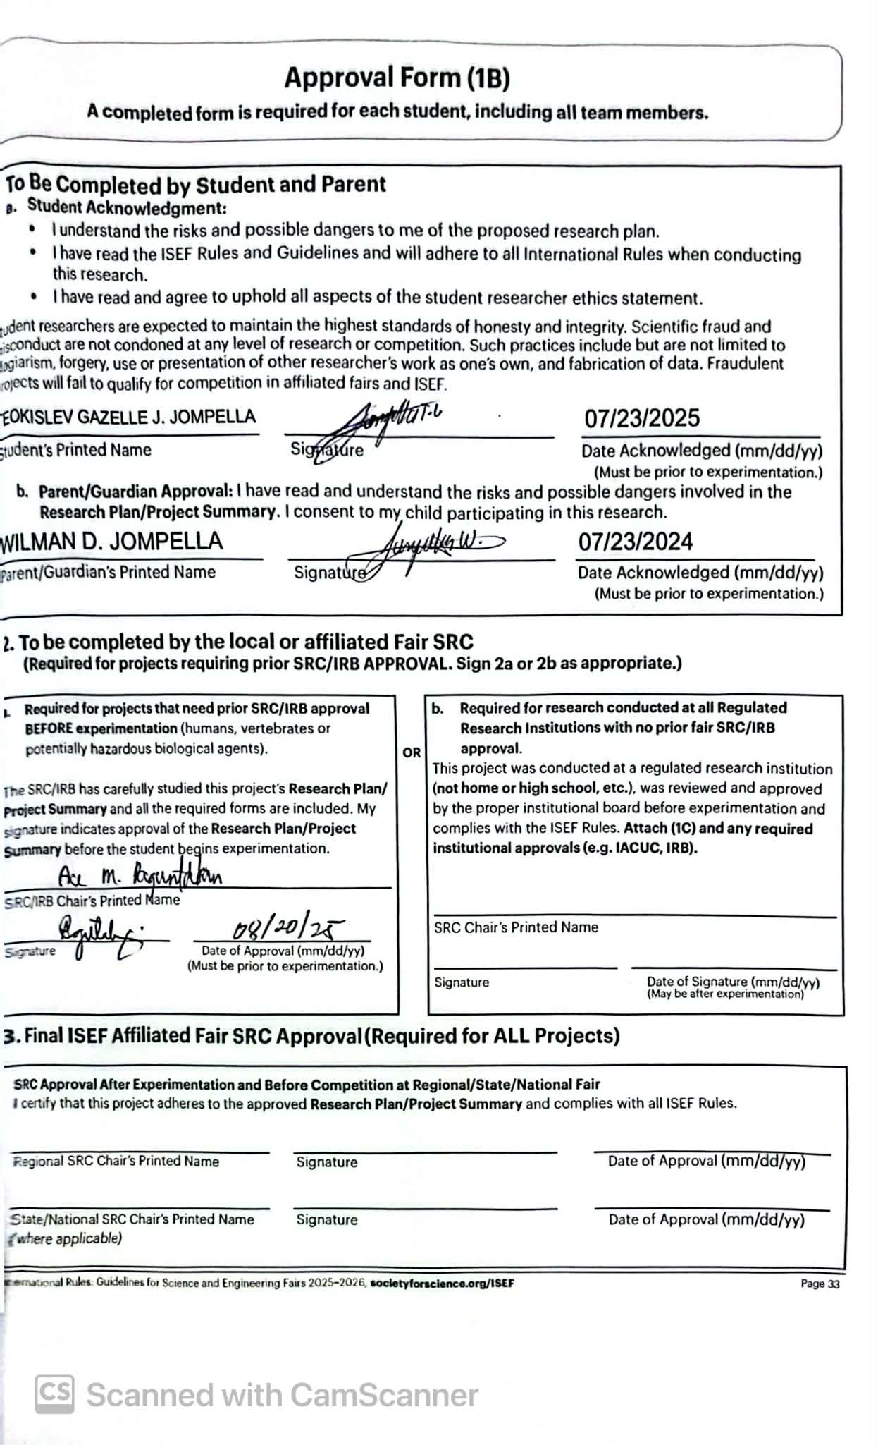

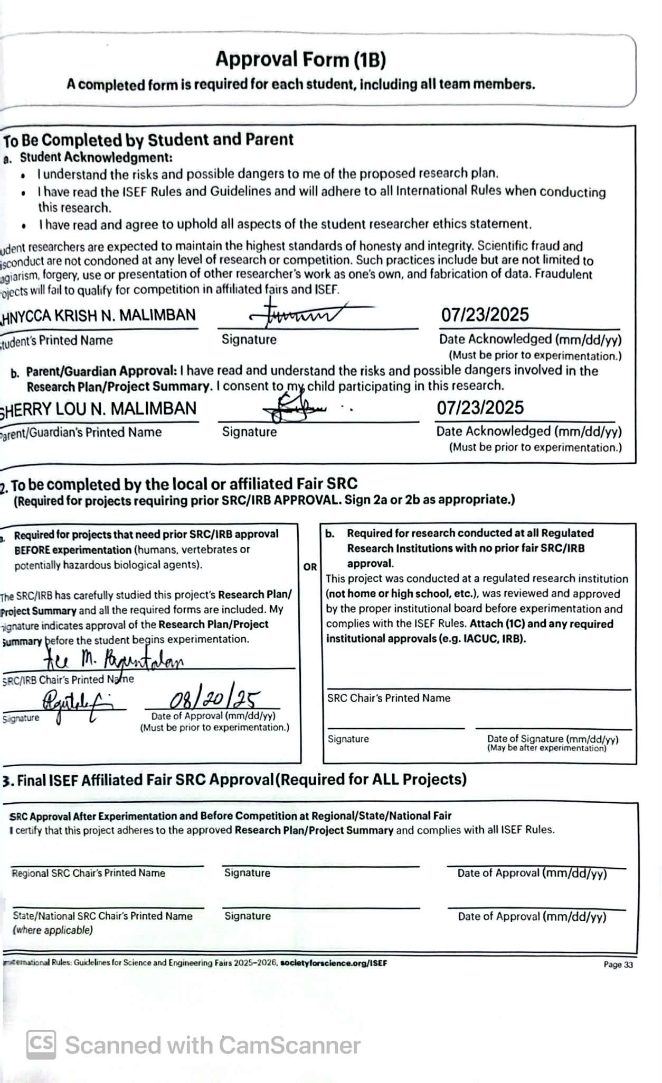

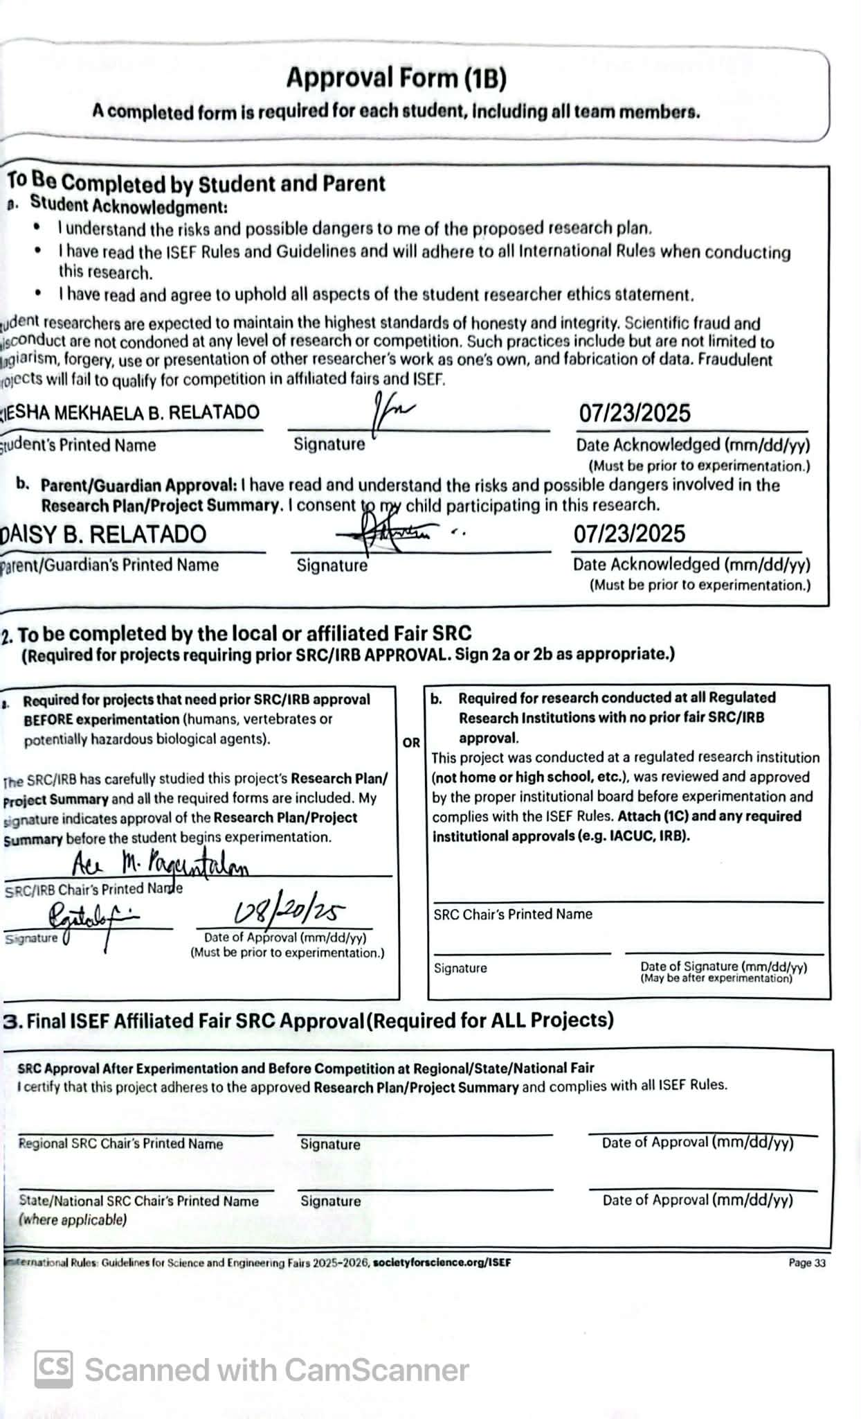

Regulated Research Institutional/Industrial Setting Form (1C)
This form must be completed AFTER experimentation by the adult supervising the student research either virtually or on site, conducted in a regulated research institution, industrial setting or
any work site other than home, school or field.
Student’s Name(s) TEOKISLEV GAZELLE J. JOMPELLA, AHNYCCA KRISH N. MALIMBAN, TEOKISLEV GAZELLE J. JOMPELLA

Title of Project

SmartSteth: A convolutional Neural Network (CNN) Driven Auscultation Instrument Using Lung Sound Analysis for Early Respiratory Disease Detection in Satellite Clinics

To be completed by the Supervising Adult in the Setting (NOT the Student(s)) after experimentation:
(Responses must be on the form as it is required to be displayed at student’s project booth; please do not print double-sided.)
Research was supported at my work site:
- The student experience at your work site included:

  - Used equipment and/or received data
  - Minimal interaction with our group
  - Mentored by me or someone else from our group
  - Worked as a sub-set of our ongoing research
  - Had an independent project from our group
Yes No
Yes No
□■
□
□■
□■
□■

□
□■
□
□
□

Yes No
Yes No
Yes No

- Please describe the independent and/or creative work done by the student in any phase of the project, but particularly in developing the hypotheses or engineering goals of the project

- Detail the student’s role in conducting the research (e.g. data collection, specific procedures performed). Differentiate what the student observed and the student actually did.

- Provide details regarding data provided to the student:

- Did the student(s) work on the project as part of a group? Yes No
□
□
Were there other high school students present? If yes, please list the students names and describe how their work was related or different from the work of this projecct.

- If this project is under a grant and needs to be acknolwedged, please list the grant statement here.

I attest that the student has conducted the work as indicated above and that any required review and approval by institutional regulatory board (IRB/IACUC/IBC) has been obtained. Copies are attached if applicable. I further acknowledge that the student will be presenting this work publicly in competition and I have communicated with the student research regarding any requirements for my review and/or restrictions of what is publicized.
Direct Supervisor’s Printed Name |  | Signature |  |  | Title
Institution |  |  |  |  | Date Signed (must be after experimenta- tion) (mm/dd/yy)
Education/Experience/Training |  |  |  |  | Email/Phone

Qualified Scientist Form (2)
May be required for research involving human participants, vertebrate animals, potentially hazardous biological agents, and hazardous substances and devices. Must be completed and signed before the start of student experimentation.

Student’s Name(s) TEOKISLEV GAZELLE J. JOMPELLA, AHNYCCA KRISH N. MALIMBAN, KIESHA MEKHAELA B. RELATADO

Title of Project SmartSteth: A convolutional Neural Network (CNN) Driven Auscultation Instrument

Using Lung Sound Analysis for Early Respiratory Disease Detection in Satellite Clinics

To be completed by the Qualified Scientist:
Scientist Name: Educational Background: Degree(s): Experience/Training as relates to the student’s area of research:

Position/Institution: Email/Phone:
- Have you reviewed the ISEF rules relevant to this project and the science fair ethics statement relevant to this project?
- Will any of the following be used?
  - Human participants
  - Animals
  - Potentially hazardous biological agents (microorganisms, rDNA and tissues, including blood and blood products)

□ No



Yes □ No
□ Yes
□
□
□
Yes □ No
Yes □ No

d. Hazardous substances and devices |   □ Yes |   □ No
3. Will this study be a sub-set of a larger study? | □ Yes | □ No
4. Will you directly supervise the student? | □ Yes | □ No
5. Did you provide any data; if yes, please provide source or describe | □ Yes | □ No

To be completed by the Qualified Scientist:
I certify that I have reviewed and approved the Research Plan/ Project Summary prior to the start of the experimentation. If the student or Direct Supervisor is not trained in the necessary procedures, I will ensure her/his training. I will provide
advice and supervision during the research. I have a working knowledge of the techniques to be used by the student in the Research Plan/Project Summary.
Qualified Scientist’s Printed Name
Signature
Date of Approval (mm/dd/yy)
To be completed by the Direct Supervisor when the Qualified Scientist cannot directly supervise.
I certify that I have reviewed the Research Plan/Project Summary and have been trained in the techniques to be used by this student, and I will provide direct supervision.
Direct Supervisor’s Printed Name

Experience/Training of Designated Supervisor
Signature
Date of Approval (mm/dd/yy)
Phone
email

Risk Assessment Form (3)
Must be completed before experimentation; recommended for all projects. May be required
for projects involving Human Participants, Hazardous Chemicals, Materials or Devices or Potentially Hazardous Biological Agents.

Student’s Name(s) TEOKISLEV GAZELLE J. JOMPELLA, AHNYCCA KRISH N. MALIMBAN, KIESHA MEKHAELA B. RELATADO

Title of Project SmartSteth: A convolutional Neural Network (CNN) Driven Auscultation Instrument

Using Lung Sound Analysis for Early Respiratory Disease Detection in Satellite Clinics

To be completed by the Student Researcher(s) in collaboration with Direct Supervisor/Qualified Scientist: (All questions must be answered; additional page(s) may be attached.)
- Identify and assess the risks and hazards involved in this project.
This project carries minimal risk since it is based on secondary datasets, surveys, and usability evaluations rather than direct patient contact or laboratory experimentation. The primary concerns are ethical, such as ensuring proper handling of anonymized data and protecting survey participants’ confidentiality.
- a) List all hazardous chemicals, activities or devices to be used; b) identify and list all microorganisms to be used that are exempt from pre-approval (see Potentially Hazardous Biological Agent rules).

No hazardous chemicals, devices, or biological agents will be used in this study. The only tools required are standard computing equipment and online survey platforms, which pose no physical danger.
- Describe the safety precautions and procedures that will be used to reduce the risks. If you conducted field work, include permits received and safety plans, as applicable.

Safety will be maintained by using only anonymized, open-source datasets and ensuring informed consent and voluntary participation in surveys. All work will be conducted under faculty supervision, with secure data storage and adherence to institutional ethical guidelines.
- Describe the specific disposal procedures that will be used (when applicable).

Temporary digital files and anonymized survey responses will be securely deleted after analysis. Any printed notes containing sensitive information will be shredded or recycled, with no hazardous waste generated.
- List the source(s) of safety information.

Safety information will be drawn from institutional research ethics guidelines, WHO recommendations on ethical health data use, IEEE/ACM computing research standards, dataset documentation from PhysioNet and ICBHI, and privacy policies of survey platforms such as Google Forms and Typeform.
To be completed and signed by the Direct Supervisor (or Qualified Scientist, when applicable):
I agree with the risk assessment and safety precautions and procedures described above. I certify that I have reviewed the
Research Plan/Project Summary and the International Rules, including the science fair ethics statement and will provide direct supervision.
Direct Supervisor’s Printed Name
Signature
Date of Review (mm/dd/yy)
Experience/Training as relates to the student’s area of research
Position/Institution
Phone or email contact information

TEOKISLEV GAZELLE J. JOMPELLA
Student’s Name(s)
KIESHA MEKHAELA B. RELATADO
Adult Sponsor
AHNYCCA KRISH N. MALIMBAN
Title of Project
SmartSteth: A convolutional Neural Network (CNN) Driven Auscultation Instrument Using Lung Sound Analysis for Early Respiratory Disease Detection in Sate

Phone/Email
MUST BE COMPLETED BY STUDENT RESEARCHER(S) IN COLLABORATION WITH THE ADULT SPONSOR/DIRECT SUPERVISOR/QUALIFIED SCIENTIST:
- □✔
- □✔

- □✔
- □✔
I have submitted my Research Plan/Project Summary which addresses ALL areas indicated in the Human Participants Section of the Research Plan/Project Summary Instructions.
I have attached any surveys or questionnaires I will be using in my project or other documents provided to human participants.
Any published instrument(s) used was /were legally obtained.
I have attached an informed consent that I would use if required by the IRB.
Yes
No
Are you working with a Qualified Scientist? If yes, attach the Qualified Scientist Form 2.
Human Participants Form (4)
Required for all research involving human participants not at a Regulated Research Institution.
If at a Regulated Research Institution, use institutional approval forms for documentation of prior review and approval. (IRB approval required before recruitment or data collection.)

□✔
□

BELOW – IRB USE ONLY
MUST be completed by Institutional Review Board (IRB) after review of the research plan. All questions must be answered for the approval to be valid. (If not approved, return paperwork to the student with instructions for modifications.)
□ Approved with Full Committee Review (3 signatures required) and the following conditions: (All 6 must be answered)
  - Risk Level (check one) : □ Minimal Risk □ More than Minimal Risk
(a risk assessment form 3 is required).
□
□
  - Qualified Scientist (QS) Required (Form 2): Yes No
  - Risk Assessment Required (Form 3): □ Yes □ No
  - Written Minor Assent and written parental permission required for minor participants:
□ Yes □ Not applicable (No minors in this study)
  - Written Informed Consent required for participants 18 years or older:
□ Yes □ No □ Not applicable (No participants 18 yrs or older in this study)
  - Facility for “protected groups” used, written approval has been obtained:
□ Yes □ No
IRB SIGNATURES (All 3 signatures required) None of these individuals may be the adult sponsor, direct supervisor, qualified scientist or related to (e.g., mother, father of) the student (conflict of interest).
I attest that I have reviewed the student’s project, that the checkboxes above have been completed to indicate the IRB determination and that I agree with the decisions above.

Medical or Mental Health Professional (a psychologist, medical doctor, licensed social worker, licensed clinical professional counselor, physician’s assistant, doctor of pharmacy, or registered nurse) with expertise related to this project.
Print Name below | Degree/Professional License
Signature | Date (prior to experimentation) | Email

Educator
Print Name below | Degree/Professional License
Signature | Date (prior to experimentation) | Email

School Administrator
Print Name below | Degree/Professional License
Signature | Date (prior to experimentation) | Email

Human Informed Consent Form
Instructions to the Student Researcher(s): An informed consent/assent/permission form should be developed in consultation with the Adult Sponsor, Direct Supervisor or Qualified Scientist.
This form is used to provide information to the research participant (or parent/guardian) and to document written informed consent, minor assent, and/or parental permission.
- When written documentation is required, the researcher keeps the original, signed form.
- Students may use this sample form or may copy ALL elements of it into a new document.
If the form is serving to document parental permission, a copy of any survey or questionnaire must be attached.
Student Researcher(s): Title of Project:
I am asking for your voluntary participation in my science fair project. Please read the following information about the project. If you would like to participate, please sign in the appropriate area below.

Purpose of the project:

If you participate, you will be asked to:

Time required for participation:

Potential Risks of Study:

Benefits:

How confidentiality will be maintained:

If you have any questions about this study, feel free to contact:

Adult Sponsor/QS/DS: Phone/email:

Voluntary Participation:
Participation in this study is completely voluntary. If you decide not to participate there will not be negative consequences. Please be aware that if you decide to participate, you may stop participating at any time and you may decide not to answer any specific question.

By signing this form I am attesting that I have read and understand the information above and I freely give my consent/ assent to participate or permission for my child to participate.
Adult Informed Consent or Minor Assent Date Reviewed & Signed: (mm/dd/yy)

Research Participant Printed Name: Signature:

Parental/Guardian Permission (if applicable) Date Reviewed & Signed:
(mm/dd/yy)

Parent/Guardian Printed Name: Signature:

Vertebrate Animal Form (5A)
Required for all research involving vertebrate animals that is conducted in a school/home/field research site. (SRC approval required before experimentation.)

Student’s Name(s) Title of Project

To be completed by Student Researcher:
- Common name (or Genus, species) and number of animals used.

- Describe completely the housing and husbandry to be provided. Include the cage/pen size, number of animals per cage, environment, bedding, type of food, frequency of food and water, how often animal is observed, etc. Add an additional page as necessary.

- What will happen to the animals after experimentation?

- Attach a copy of wildlife licenses or approval forms, as applicable
- The ISEF Vertebrate Animal Rules require that any death, illness or unexpected weight loss be investigated and documented by a letter from the qualified scientist, direct supervisor or a veterinarian. If applicable, attach this letter with this form when submitting your paperwork to the SRC prior to competition.
Date of Approval (mm/dd/yy)
Signature
Email/Phone
Printed Name
To be completed by Direct Supervisor or Qualified Scientist when applicable:
□ I have reviewed this research and animal husbandry with the student before the start of experimentation and I accept primary responsibility for the care and handling of the animals in this project.
□ I will directly supervise the experiment.
Date of Approval (must be prior to experimentation) (mm/dd/yy)
Signature
SRC Chair Printed Name
To be completed by Local or Affiliate Fair Scientific Review Committee (SRC) BEFORE experimentation.
Level of Supervision Required for agricultural, behavioral or nutritional studies (select one):
□ Direct Supervisor REQUIRED. Please have applicable person sign below.
□ Veterinarian and Direct Supervisor REQUIRED. Please have applicable persons sign below.
□ Veterinarian, Direct Supervisor and Qualified Scientist REQUIRED. Please have applicable persons sign below and have the Qualified Scientist complete Form (2).
The SRC has carefully reviewed this study and finds it is an appropriate study that may be conducted in a non-regulated research site.
Local or Affiliate Fair SRC Pre-Approval Signature:
Date of Approval (mm/dd/yy)
Signature
Email/Phone
Printed Name
To be completed by Veterinarian:
□ I have reviewed this research and animal husbandry with the student before the start of experimentation.
□ I have approved the use and dosages of prescription drugs and/or nutritional supplements.
□ I will provide veterinary medical and nursing care in case of illness or emergency. (Fees may apply.)

Vertebrate Animal Form (5B)
Required for all research involving vertebrate animals that is conducted in at a Regulated Research Institution. (IACUC approval required before experimentation. Form must be completed and signed after experimentation.)
Student’s Name(s)
Title of Project Title and Protocol Number of IACUC Approved Project

To be completed by Qualified Scientist or Principal Investigator:
- Species of animals used: Number of animals used:

- Describe, in detail, the role of the student in this project: animal procedures and related equipment that were involved, oversight provided and safety precautions employed. (Attach extra pages if necessary.)

- Was there any weight loss or death of any animal? If yes, attach a letter obtained from the qualified scientist, direct supervisor or a veterinarian documenting the situation and the results of the investigation.


- Did the student’s project also involve the use of tissues? No
□
□
Yes; complete Forms 6A and 6B
- What laboratory training, including dates, was provided to the student?

- Attach a copy of the Regulated Research Institution IACUC Approval. A letter from the Qualified Scientist or Principal Investigator is not sufficient.

Qualified Scientist/Principal Investigator
Printed Name | Date (mm/dd/yy)
Signature | Date (mm/dd/yy)

Potentially Hazardous Biological Agents Risk Assessment Form (6A)
Required for research involving microorganisms, rDNA, fresh/frozen tissue (including primary cell lines, human and other primate established cell lines and tissue cultures), blood, blood products and body fluids.
SRC/IACUC/IBC approval required before experimentation.

Student’s Name(s) Title of Project
To be completed by the QUALIFIED SCIENTIST/DIRECT SUPERVISOR in collaboration with the student researcher(s). All questions are applicable and must be answered; additional page(s) may be attached.
SECTION 1: PROJECT ASSESSMENT
- Identify potentially hazardous biological agents to be used in this experiment. Include the strain, source, quantity and the biosafety level risk group of each microorganism.

- Describe the biosafety level of the experimentation site.

- Describe the procedures that will be used to minimize risk (personal protective equipment, safety cabinet type, etc.).

- Describe the method of disposal of all cultured materials and other potentially hazardous biological agents. If BSL-2 laboratory, not at an RRI, include the BSL-2 checklist

SECTION 2: TRAINING
- What training will the student receive for this project?

- Experience/training of Direct Supervisor as it relates to the student’s area of research (if applicable).

SECTION 3: For ALL CELL LINES, MICROORGANISMS AND TISSUES – To be completed by the QUALIFIED SCIENTIST
or Direct Supervisor - Check the appropriate box(es) below:
□ Experimentation on the microorganisms/cell lines/tissues to be used in this study will NOT be conducted at a Regulated Research Institution, but will be conducted at a (check one) BSL-1 or BSL-2 laboratory (include a copy of the checklist for BSL-2. [This study has been reviewed by the local SRC and the procedures have been approved prior to experimentation.]
□ This project involves the culturing of Multi Drug Resistant Organisms (MDROs). It has been conducted in a BSL-2 or higher lab at a Regulated Research Institution and the required IBC pre-approval is attached.
Date of IBC approval
□ Experimentation on the microorganisms/cell lines/tissues to be used in this study will be conducted at a Regulated Research Institution and was approved by the appropriate institutional board prior to experimentation; institutional approval forms are attached.
Origin of cell lines: Date of IBC/IACUC approval
□ Experimentation on the microorganisms/cell lines/tissues to be used will be conducted at a Regulated Research Institution, which does not require IACUC or IBC approval for this type of study.
CERTIFICATION – To be SIGNED by the QUALIFIED SCIENTIST or Direct Supervisor
The QS/DS has seen this project’s research plan and supporting documentation and acknowledges the accuracy of the information provided above. This study has been approved as a (check one) □ BSL-1/ □ BSL-2 study, and will be conducted in an appropriate laboratory.

QS/DS Printed Name Signature Date of review (mm/dd/yy)

Human and Vertebrate Animal Tissue Form (6B)
Required for research involving fresh/frozen tissue (including primary cell lines, human and other primate established cell lines and tissue cultures), blood, blood products and body fluids. If the research involves living organisms please ensure that the proper human or animal forms are completed. All projects using any tissue listed above must also complete Form 6A.

Student’s Name(s) Title of Project To be completed by Student Researcher(s):
- What vertebrate animal tissue will be used in this study? Check all that apply.
□ Fresh or frozen tissue sample
□ Fresh organ or other body part

□ Blood
□ Body fluids
□ Primary cell/tissue cultures
□ Human or other primate established cell lines

- Where will the above tissue(s) be obtained? If using an established cell line include source and catalog number.

- If the tissue will be obtained from a vertebrate animal study conducted at a research institution attach a copy of the IACUC certification with the name of the research institution, the title of the study, the IACUC approval num- ber and a copy of IACUC approval. If human tissues were used, attach a copy of IRB approval.

To be completed by the Qualified Scientist or Direct Supervisor:
□ I verify that the student will work solely with de-identified organs, tissues, cultures or cells that will be supplied to him/her by myself or qualified personnel from the laboratory; and that if vertebrate animals were euthanized they were euthanized for a purpose other than the student’s research.
AND/OR
□ I certify that the blood, blood products, tissues or body fluids in this project will be handled in accordance with the standards and guidance set forth in U.S. Occupational Safety and Health Act, 29CFR, Subpart Z, 1910.1030 - Blood Borne Pathogens.
Printed Name
Signature
Date of Approval (mm/dd/yy)
(Must be prior to experimentation.)
Title
Phone/Email
Institution

Continuation/Research Progression Projects Form (7)
Required for projects that are a continuation/progression in the same field of study as a previous project. This form must be accompanied by the previous year’s abstract and Research Plan/Project Summary.
Student’s Name(s)

To be completed by Student Researcher: List all components of the current project that make it new and different from previous research.

Components | Current Research Project | Previous Research Project: Year:
1. Title
2. Change in goal/ purpose/objective
3. Changes in methodology
4. Variable studied
5. Additional changes

Attached are:
□
□
Previous year’s Abstract and Research Plan/Project Summary, Year Previous Form 7s, if applicable.
I hereby certify that the above information is correct and that the current year Abstract & Certification and project display board properly reflect work done only in the current year.
Student’s Printed Name(s)
Signature
Date of Signature (mm/dd/yy)

